

Project Proposal
(E-BAKERS)
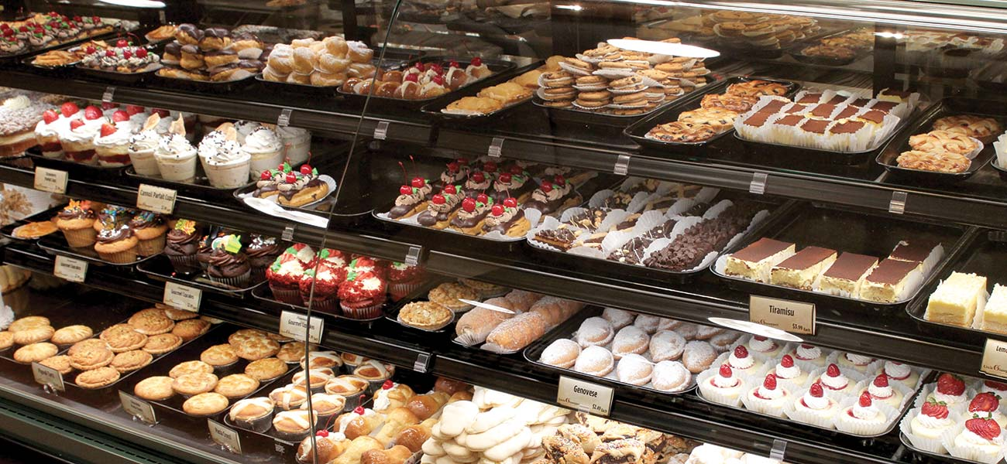

Submitted by:
DHARA KUMARI RAJPUT
HAFIZ ABDUL WAHEED
MUHAMMAD AMMAD ANSARI
HUZAIFA ALI
SHEHERYAR TAMIMI
Submitted to:
SIR MANSOOR EBRAHIM

< GitHub Repository Link : https://github.com/dhararajput-official/E-bakers.git >
Project Proposal

Section – 1

Project Identification
Project Title:
<E Bakers>

Group Leader (GL):
1. | Name: | Dhara Kumari Rajput
 | Reg #: | 49481
 | CGPA: | 3.24
 | Mobile # : | 03313105255 | Email: |  | Dhararajput.official@gmail.com
 | Signature: | Dhara
Group Members (GM’s):
2. | Name: | Hafiz Abdul Waheed
 | Reg #: | 41342
 | CGPA: | 2.95
 | Mobile # : | 03352351049 |  | Email: |  | Waheedrasheed863@gmail.com
 | Signature: | Waheed
3. | Name: | Muhammad Ammad Ansari
 | Reg #: | 41663
 | CGPA: | 3.03
 | Mobile # : | 03112335680 |  | Email: |  | Ammadansari45@gmail.com
 | Signature: | Ammad
4. | Name: | Huzaifa ali
 | Reg #: | 41277
 | CGPA: | 2.7
 | Mobile # : | 03152798152 |  | Email: |  | Shaikhhuzaifa790@gmail.com
 | Signature: | Huzaifa
5. | Name: | Sheheryar tamimi
 | Reg #: | 49611
 | CGPA: | 2.5
 | Mobile # : | 03362486899 |  | Email: |  | sheheryartamimi@gmail.com
 | Signature: | Sheheryar

What technology is core to your product? (Please mark ☑ where applicable)
[ ] 3D/4D Printing |  | [ ] Augmented Reality / Virtual Reality
[ ] Big Data, Artificial Intelligence |  | [ ] Blockchain
[ ] Cloud |  | [ ] Neurotech
[ ] Robotics |  | [ ] Shared economy
[ ] The Internet of Things |  | [ ] Wearables, Implantable
[ ] Others (specify): | PROGRESSIVE WEB APPLICATION

What is the target market(s) for the products? (Please mark ☑ where applicable)
[ ] Automotive, aviation, marine |  | [ ] Business, marketing, finance
[ ] Defence, security, safety |  | [ ] Education and training
[ ] Environment, water management |  | [ ] Entertainment, tourism, sport/recreation
[✓] Food, livestock, agribusiness |  | [ ] Healthcare
[ ] Infrastructure, housing & transport |  | [ ] Mining equipment technology & services
[ ] Oil, gas, energy |  | [ ] Textiles, clothing, footwear
[ ] Others (specify):

Other Organizations Involved in the Project: (Please identify all affiliated organizations collaborating in the project, and describe their role/contribution to the project.)
Academic Organizations:
# | Organization Name |  |  | Role / Contribution
 | Iqra University |  |  | -
 | - |  |  | -
Industrial Organizations:
# | Organization Name |  | Role / Contribution
 | - |  | -
 | - |  | -
Funding Organizations:
# | Organization Name |  |  | Role / Contribution
 | - |  |  | -
 | - |  |  | -
Key Words: (Please provide a maximum of 5 keywords that describe the project)
IT Solutions, PWA, Website, Smart Solution, Device Independent
Project Status: (Please mark ☑)
[✓] New [ ] Modification to previous Project
[ ] Extension of existing project

Project Duration: |  | 1 Month
Proposed Budget: |  | - 10,000 PKR
Project Description (what you want to do)
(Provide a simple, high-level description of the project that clearly states the overall business goal of the initiative. If the description is highly technical or utilizes acronyms, please provide a one paragraph summary in layman’s terms of the project.)

We are going to develop an E-Bakers online website. This website will give same look and feel as a responsive website. It will give you all types of benefit like the online website, and it won’t take time to load on chrome , and it will open in any device. Also in this website it has several pages on demand of the client, we will provide online purchasing, online order, and many offers.

Project Justification (why you want to do this)
(A simple, high-level description of the benefits the project will achieve (generally a paragraph or less).

By making this website those who are going to the bakery for purchasing any bakery item, so they don’t need to go anywhere, they can use this website for online purchasing the bakery items. It enhance the capabilities of online bakery website that allow creating an immersive user experience and increase user engagement and conversion rate.

WHY CHOOSE E-Bakers?
- Open in any device.
- Fast and accurate Response.
- Updating all new items and discounts.
- Fast delivery
- Easy to use
- User Friendly
We will use the following techniques/tools to achieve the final product.
(Maximum 200 words.)
We will use HTML to create the website’s basic structure then we will apply CSS (Bootstrap) to format the layout of the website and add colors to it and make the website responsive. Once designing is done we will add functionality to the website with JavaScript. With the help of it we can make dynamic and interactive web pages.And we will use C# and Sql for making Database.

Synopsis:
(A brief description of the idea, in non-technical language, explaining product benefit, target market, basic technology, commercial partners, investors, and potential customers. Maximum 200 words.)
We will make a Responsive Online Bakers Website with several pages for every same type of item, special offers and discount for Bakery Buisness which will work reliably on any device and platform.

Section – 2

2.1 Background
Scope of the Project:
The users can simply browse the website and use it and they will certainly experience great results. They will experience the online bakery system and delivery.
.

Challenges: (Please describe the challenges, specific to this research topic, currently being faced internationally. Maximum 500 words.)
A E-Bakers website is a responsive website.
Basic Challenges:
Approach

Responsive

Content Positioning and Clarity

Taking delivery online

Smooth User Experience

Simple Designing
- Open in any browser

Motivation and Need: (Please describe the motivation and need for this work. Maximum 500 words.)
Our Motivation is Hisham Sarwar who is in the list of world top freelancer , he is a motivation for everyone that anyone can start earning . when he can start freelancing without any computer course so why we can’t start freelancing by establishing start up ,under the niche of Dope-Tech we will do work for our clients ,all the members of Dope-Tech could start freelancing together , by working together.

2.2 Outcomes and Benefits
Expected Outcomes: (Provide a list of proposed project outputs including publications, databases etc.)

Everyone can make their order, get food on time, give attention to each customer
Customers can ask for any type of Tech application for themselves as it will have easy user interface and can access the website from any platform.

Key Benefits and Beneficiaries: (Please identify clearly the benefits and potential customers/beneficiaries of the project.)

Benefits of E-Bakers:
- Friendly user.
- Open in any device.
- Open in and web browser.
- Giving discount on regular customer
- Many varieties are available
- Use hygienic food

2.3 Objectives
(Please describe the measurable objectives of the project and define the expected results. Use results-oriented wording with verbs such as ‘to develop..’, ‘to implement..’, ‘to research..’, ‘to determine..‘, ‘to identify..’ The objectives should not be statements and should actually specify in simple words what the project team intends to achieve (something concrete and measurable/ deliverable). Fill only those objectives that are applicable to the proposed project.)
It will provide a simple and interactive single platform for the customers for making order .User will be able to access it from any device.

Key Milestones and Deliverables:
(Please list and describe the principal milestones and associated deliverables of the project. The timing of milestones is also to be shown in the Gantt chart in Annexure-A. Quarterly deliverables are preferred.)
- - -
S. No. | Elapsed time since start of the project | Milestone | Deliverable
1. | Week 01 | Feasibility study and Project Plan | -
2. | Week 02 | UI Designing | -
3. | Week 03 | Backend Connectivity | -
4. | Week 04 | Testing and Implementation | -
(Please add more rows if required.)

Section – 3

3.1 Resources & Other Requirements
Project Team:
The numbers in the table below must tally with the HR Cost sheet in the Budget file.
Title / Position | Number
Team Leads | 1
Researchers / Developers | 4
Researcher / Development Assistants | -
Support Staff | -
Contract Staff (please specify) | -
Others (please specify) | -
Add more rows if required | -
Team Structure:
(Please define the team structure (organogram) and role/key responsibilities of each member. If in collaboration with another partner, the division of manpower at various locations of partners be provided.)
Title/Position  (of each member) | Role/Key Responsibilities | Minimum Qualification Required | Expertise / Background Required | Minimum Experience Required (years)
Dhara Kumari Rajput | Responsive Front-End and backend | - | - | -
Hafiz Abdul Waheed | Responsive Front-End and backend | - | - | -
Muhammad Ammad Ansari | Responsive Front-End and Backend | - | - | -
Huzaifa Ali | Responsive Front-End and Designing
Sheheryar Tamimi | Responsive Front-End and Designing

CLIENT INTERACTION DETAILS:

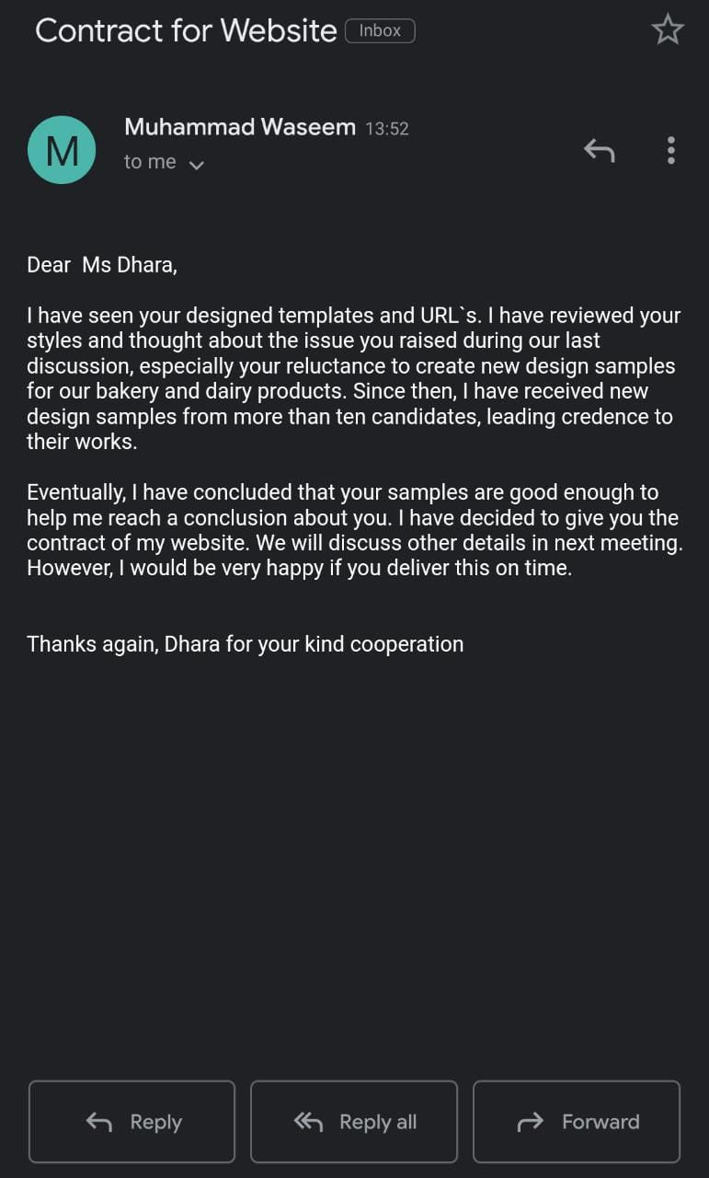

Remarks:

1. Name & Signature of client:

2. Name & Signature of Faculty:

